CSCW-415: Software Quality and Metrics

Labs

Lab 7: Halstead Metrics

As you know that Halstead software metrics are used to calculate program size and other relevant attributes like program vocabulary, volume, difficulty, effort, and time required to code a program. In today’s lab we will apply the Halstead’s metrics on two different programs. You can also test it on your programs you have already developed.

Task 1:

Make a separate table for the following code. In table; include a list of total operators, total operands, unique operators, unique operands, the occurrences of operators and operands. Furthermore, calculate program length, vocabulary, difficulty, effort, and programming time.

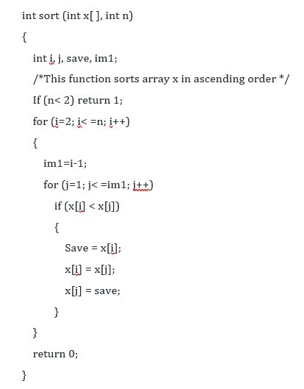

|  |  |  |  |
| --- | --- | --- | --- |
| operators | occurrences | operands | occurrences |
| int | 4 | sort | 1 |
| () | 5 | x | 7 |
| , | 4 | n | 3 |
| ; | 11 | j | 7 |
| for | 2 | save | 3 |
| = | 6 | im1 | 3 |
| <= | 2 | 2 | 2 |
| ++ | 2 | 1 | 3 |
| - | 1 | 0 | 1 |
| return | 2 |  |  |
| {} | 3 |  |  |
| n1=14 | N1=53 | n2=10 | N2=38 |

Program length: N=N1+N2

N=53+38=91

Program vocabulary: n=n1+n2

n=14+10=24

program difficulty: D=(n1/2)*(N2/n2)

D=(14/2)*(38/10)=7*3.8=26.6

Program effort: E=D*V

V=N*log2(n)

V=91*log2(24)=417.23

E=417.23*26.6=11098.318

Programming time: T=E/18

11098.318/18=616.573

Chapter 5, slide 38

Task 2:

Make a separate table for the following code. In table; include a list of total operators, total operands, unique operators, unique operands, the occurrences of operators and operands. Furthermore, calculate program length, vocabulary, difficult, effort, and programming time.

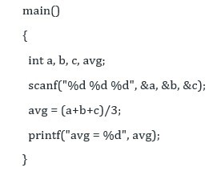

|  |  |  |  |
| --- | --- | --- | --- |
| operators | occurrences | operands | occurrences |
| int | 1 | main | 1 |
| () | 3 | a | 2 |
| , | 7 | b | 2 |
| ; | 4 | c | 2 |
| {} | 1 | avg | 3 |
| scanf | 1 | + | 2 |
| printf | 1 | / | 1 |
|  |  | 3 | 1 |
|  |  | = | 1 |
| n1=7 | N1=18 | n2=9 | N2=15 |

Program length: N=N1+N2

N=18+15=33

Program vocabulary: n=n1+n2

n=7+9=16

program difficulty: D=(n1/2)*(N2/n2)

D=(7/2)*(15/9)=3.5*1.67=5.845

Program effort: E=D*V

V=N*log2(n)

V=18*log2(16)=72

E=5.845*72=420.84

Programming time: T=E/18

420.84/18=23.38

اجتهاد شخصي

Task 3:

This task should be completed after you have completed Task1 and Task2.

Go to the following website and use the Halstead calculator to verify the results of Task 1 and Task 2.

<http://groups.umd.umich.edu/cis/tinytools/cis375/f18/team3-halsteadcalculator/index.html>